| **Test Name** | | | User Can Scroll On The All Sensors Summary Page | | | |
| --- | --- | --- | --- | --- | --- | --- |
| **Use Case Tested:** | | | View & Scroll All Sensors | | | |
| **Test Description:** | | | The user navigates to the all sensors summary page, the user is able to scroll through the page to see all the sensors at once. | | | |
| **Pre-conditions** | | |  | | | |
| **Post-conditions** | | | The user is able to see all 11 sensors. | | | |
| **Notes:** | | **Unsure how else to demonstrate a button click other than through screenshots.** | | | | |
| **Result (Pass/Fail/Warning/Incomplete)** | | **Pass** | | | | |
|  | **TEST STEP** | | | **EXPECTED TEST RESULTS** | P | F |
|  | Click On Sensors On Menu | | | All Sensors Window Is Displayed | X |  |
|  | Select The Data Menu Option | | | Drop down menu is displayed | X |  |
|  | Select the “All Salinity Levels” option | | | The “All Salinity Levels” Window is Displayed | X |  |
|  | Scroll from left to Right And Then from top to bottom | | | The Window Scrolls | X |  |

**Test Output Screenshots**

Start

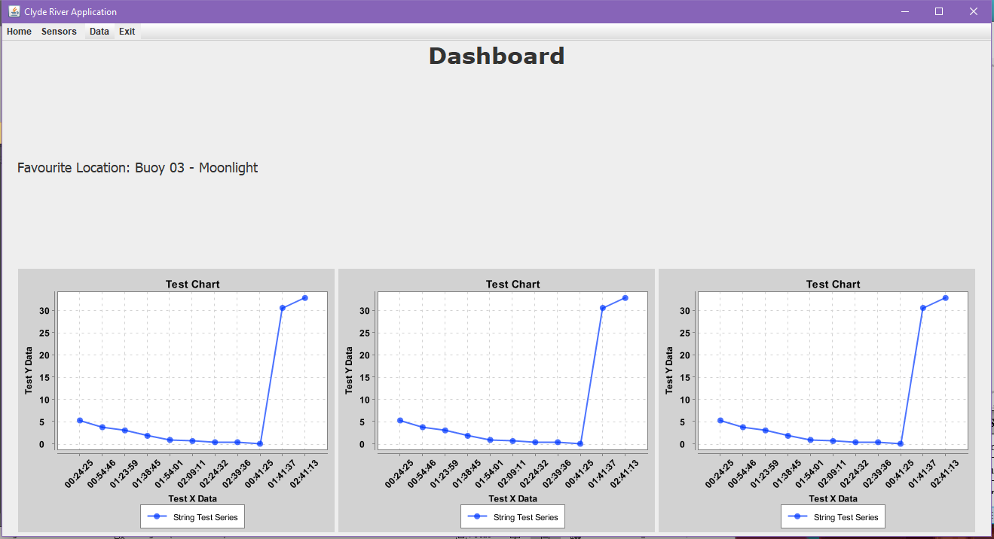

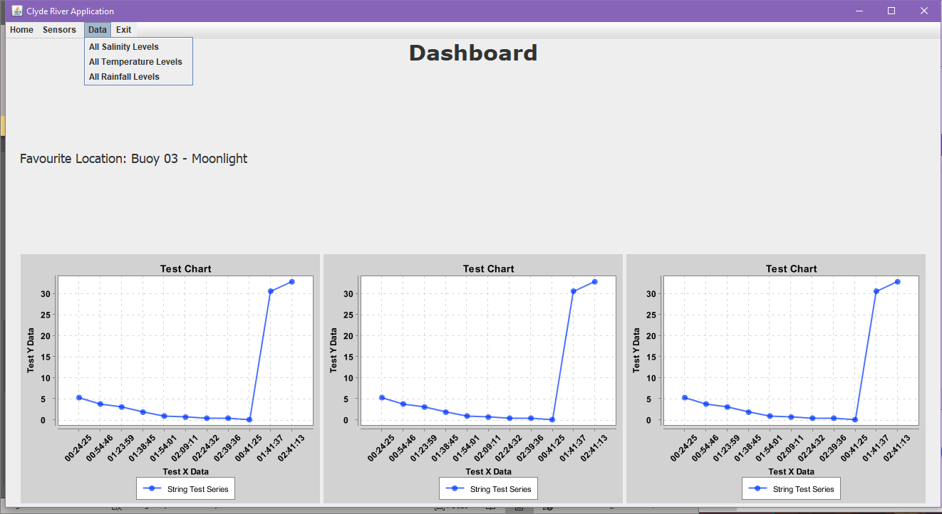

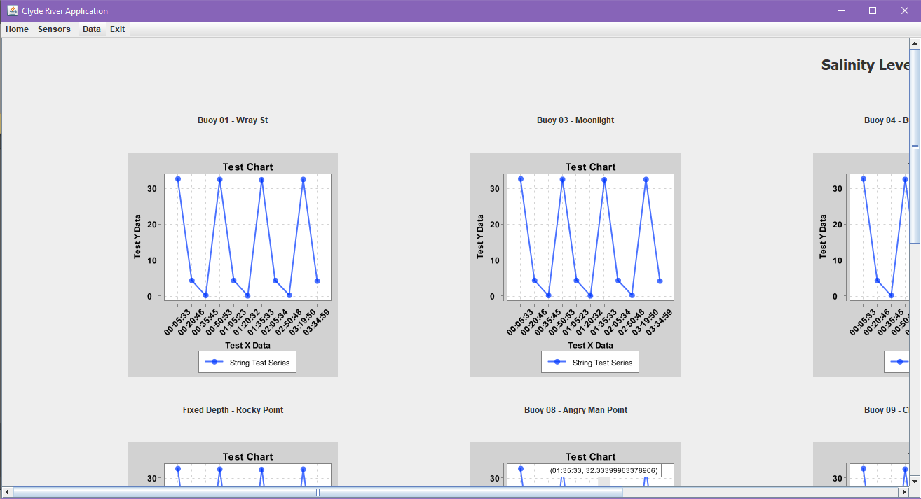

Result

